1. Exploratory data analysis

The data is recorded every second, there are approximate 2 millions rows in “input_dataset-2.parquet” and more than 8 millions rows in “input_dataset-2.parquet”.

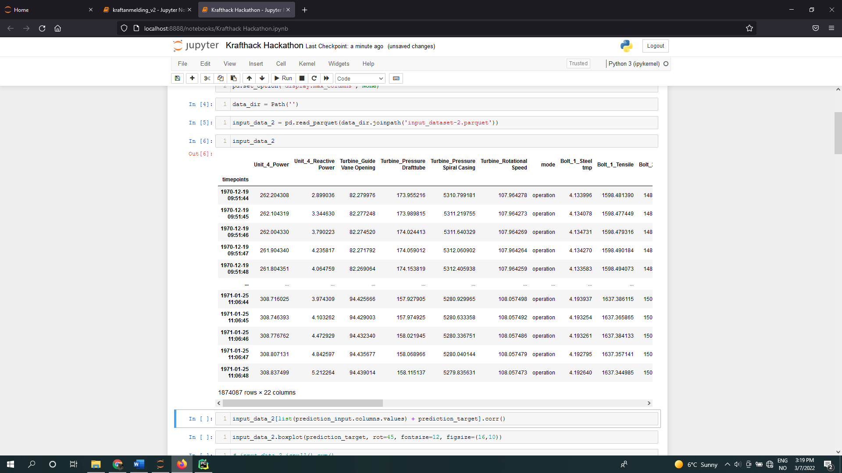

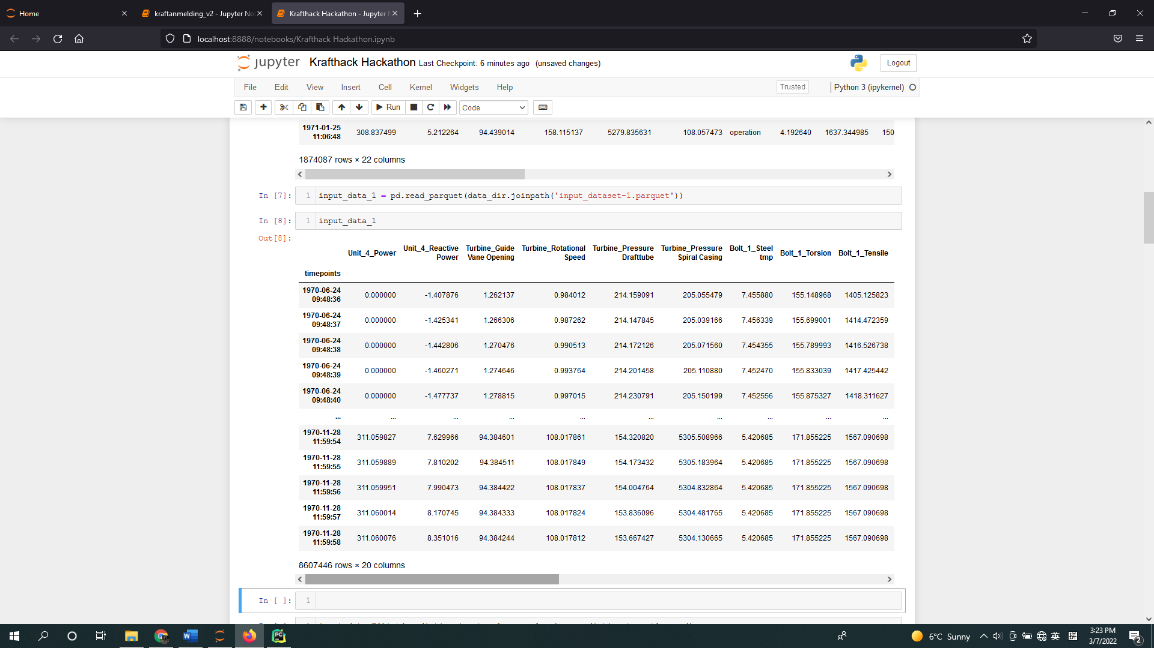

According to “prediction_input.parquet”, we need to use 'Unit_4_Power', 'Unit_4_Reactive Power', 'Turbine_Guide Vane Opening', 'Turbine_Pressure Drafttube', 'Turbine_Pressure Spiral Casing', 'Turbine_Rotational Speed', and 'mode' as inputs for the prediction, make 6 models for the tensile of each bolt ('Bolt_1_Tensile' to 'Bolt_6_Tensile'), so we merge the two input datasets using the prediction and target columns mentioned above.

The correlation matrix shows that the correlation between the input values and target values are quite low.

The box plot indicates that 'Bolt_2_Tensile' has quite unique behaviors, 'Bolt_4_Tensile', 'Bolt_5_Tensile' and 'Bolt_6_Tensile' have more outliers than the other three bolts.

1. Model training

There are over 10 millions data in the data set, due to large amount of dataset, the model is too slow to be trained (even with GPU), so we used only “input_dataset-2.parquet” to train the model

Because the ‘mode’ is a string, we encoded it into one hot variable (‘mode_operation’ and ‘mode_start’ in the above picture).

We further divided the dataset into train and test, then scaled the data, considering the outliers in the dataset, we used RobustScaler.

We tested several different models and parameters, including Xgboost, SVR, neural network etc., even we only use “input_dataset-2.parquet” to train the model, the neural network is still too slow to be trained (even with GPU), so from reproduction aspect and consider the real life application (in real life scenario, we may need to train many models for many generators, and retrain the model from time to time according to latest data), we finally selected Xgboost as the major model.

1. Production

In considering future production, we implemented a retrain_model function, this function could loop through all the potential models and parameters, which are reasonable models and parameter ranges we found in step 2, we think these models and parameter ranges are good candidates for future scenario.

The physical conditions of the generator may change in the future, by implementing these candidate models, the users who is a domain expertise but don’t have too much data science knowledge can retrain the model and control the model used in the production easily.

Detailed code about the retrain_model function is in the hackathon_train.py file.